**Create a repo using the web portal**

1. Open the **Repos** page in your project by browsing to https://dev.azure.com/OrganizationName, hover your mouse over the name of your project, and select the **Repos** icon. You can select it from the **All** projects list, or from the **Recent** projects list if you've accessed it recently.

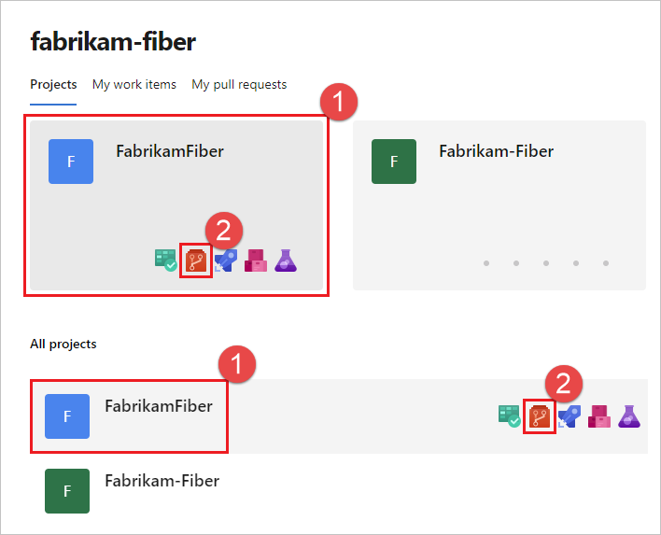

1. From the repo drop-down, select **New repository**.

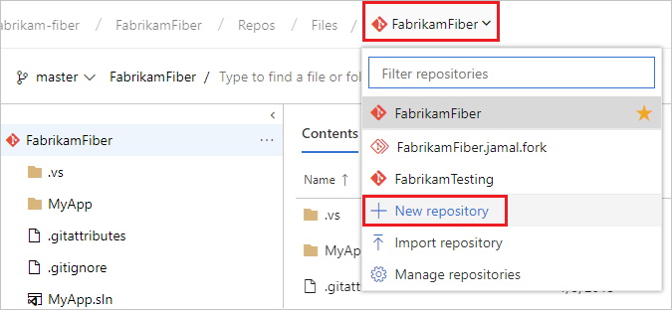

1. In the **Create a new repository** dialog, verify that Git is the repository type and enter a name for your new repository. For naming restrictions, see [Naming restrictions, Azure Repos (git)](https://learn.microsoft.com/en-us/azure/devops/organizations/settings/naming-restrictions?view=azure-devops#repos-git).

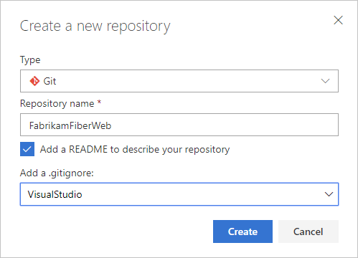

You can also add a README and create a .gitignore for the type of code you plan to manage in the repo. A [README](https://learn.microsoft.com/en-us/azure/devops/repos/git/create-a-readme?view=azure-devops) contains information about the code in your repo. The [.gitignore](https://learn.microsoft.com/en-us/azure/devops/repos/git/ignore-files?view=azure-devops) file tells Git which types of files to ignore, such as temporary build files from your development environment.

1. When you're happy with the repo name and choices, select **Create**.

A new empty Git repo is now created in your project.

* + If you created an empty repo with no README or .gitignore files, you'll see instructions on how to [clone](https://learn.microsoft.com/en-us/azure/devops/repos/git/clone?view=azure-devops) the repo to your computer. You'll also see instructions on how to [push](https://learn.microsoft.com/en-us/azure/devops/repos/git/pushing?view=azure-devops) code in an existing repo into the newly created one.
  + In this example, you created a README and a .gitignore. You'll now see an overview of the files in your repo. You can [clone](https://learn.microsoft.com/en-us/azure/devops/repos/git/clone?view=azure-devops) the repo using the **Clone** link on the upper right of the page to get working with a local copy of the repo immediately.

**Clone the repo to your computer**

To work with a Git repo, you clone it to your computer. Cloning a repo creates a complete local copy of the repo for you to work with. Cloning also downloads all [commits](https://learn.microsoft.com/en-us/azure/devops/repos/git/commits?view=azure-devops) and [branches](https://learn.microsoft.com/en-us/azure/devops/repos/git/create-branch?view=azure-devops) in the repo and sets up a named relationship with the repo on the server. Use this relationship to interact with the existing repo, pushing and pulling changes to share code with your team.

1. From your web browser, open the team project for your organization in Azure DevOps and select **Repos** > **Files**. If you don't have a team project, [create one now](https://learn.microsoft.com/en-us/azure/devops/repos/get-started/sign-up-invite-teammates?view=azure-devops).

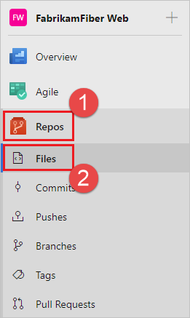

1. Select **Clone** in the upper-right corner of the **Files** window and copy the clone URL.

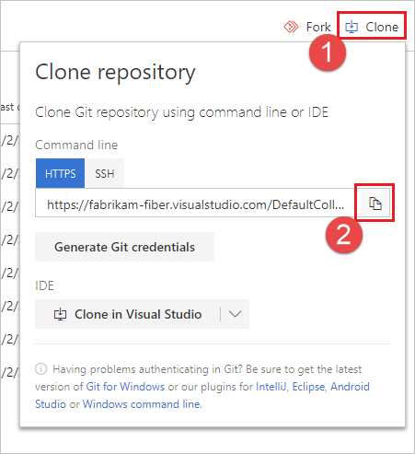

1. Open the Git command window (Git Bash on Git for Windows). Then, browse to the folder where you want the code from the repo stored on your computer. Run git clone followed by the path copied from the **Clone URL** in the previous section, as shown in the following example.

Copy

git clone https://dev.azure.com/fabrikam-fiber/MyFirstProject/_git/

Git downloads a copy of the code into a new folder for you to work with. The download includes all [commits](https://learn.microsoft.com/en-us/azure/devops/repos/git/commits?view=azure-devops) and [branches](https://learn.microsoft.com/en-us/azure/devops/repos/git/create-branch?view=azure-devops) from the repo.

1. Switch your directory to the repository that you cloned.

Copy

cd fabrikam-fiber

Keep this command window open, because you'll use it in the following steps.

**Work with the code**

In this step, we'll make a change to the files on your computer, commit the changes locally, push the commit up to the repo on the server, and view the changes there.

1. Browse to the folder on your computer where you cloned the repo and open the README.md file in your editor of choice.
2. Make some changes, for example add This is my first edit. to the file, and save and close the file.
3. In the Git command window, navigate to the fabrikam-fiber directory by entering the following command:

Copy

cd fabrikam-fiber

1. Commit your changes by entering the following command in the Git command window:

Copy

git commit -a -m "My first commit"

When using git commit, -a means to commit all changed files, and -m specifies a commit message.

1. Push your changes up to the Git repo by entering the following command into the Git command window:

Copy

git push

1. Switch back to the web portal and select **History** from the **Code** view to view your new commit. The new repo has two commits. The first is the commit where the README and .gitignore were added when the repo was created. The second is the commit you just made.

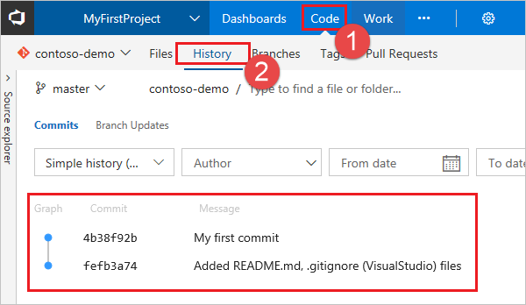

1. Switch to the **Files** tab and select the README file to view your changes.

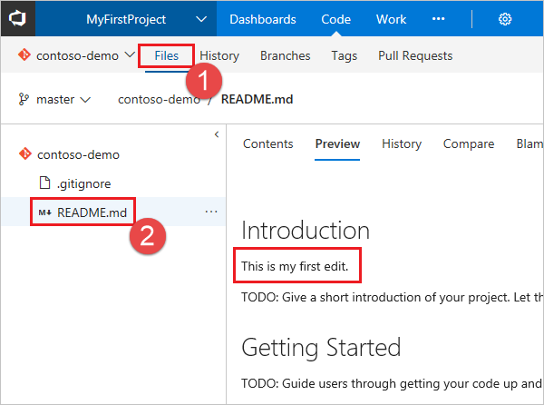

**Next steps**

**Create a project**

You can create up to 1000 projects within an organization in Azure DevOps. For more information, see [Work tracking, process, and project limits](https://learn.microsoft.com/en-us/azure/devops/organizations/settings/work/object-limits?view=azure-devops).

* [Browser](https://learn.microsoft.com/en-us/azure/devops/organizations/projects/create-project?view=azure-devops&tabs=browser#tabpanel_1_browser)
* [Team Explorer](https://learn.microsoft.com/en-us/azure/devops/organizations/projects/create-project?view=azure-devops&tabs=browser#tabpanel_1_team-explorer)
* [Azure DevOps CLI](https://learn.microsoft.com/en-us/azure/devops/organizations/projects/create-project?view=azure-devops&tabs=browser#tabpanel_1_azure-devops-cli)

1. Sign in to your organization (https://dev.azure.com/{yourorganization}).
2. Select **New project**.

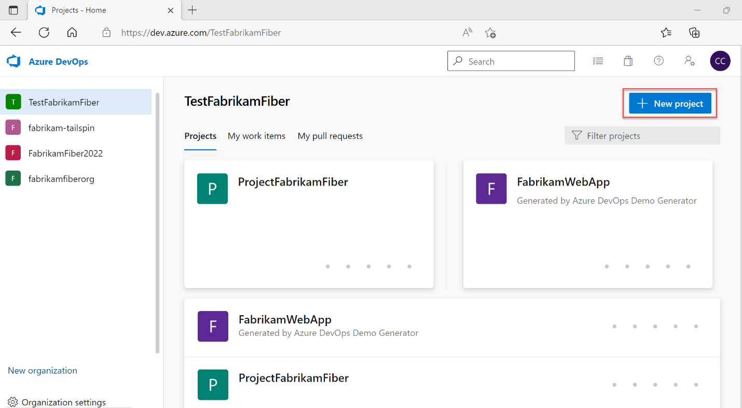

1. Enter information into the form provided.
   * Provide a name for your project. Your project name can't contain special characters, such as / : \ ~ & % ; @ ' " ? < > | # $ * } { , + = [ ], can't begin with an underscore, can't begin or end with a period, and must be 64 or fewer characters.
   * Enter an optional description.
   * Choose the visibility, initial source control type, and work item process. For more information, see [Choosing the right version control for your project](https://learn.microsoft.com/en-us/azure/devops/repos/tfvc/comparison-git-tfvc?view=azure-devops) and [Choose a process](https://learn.microsoft.com/en-us/azure/devops/boards/work-items/guidance/choose-process?view=azure-devops).

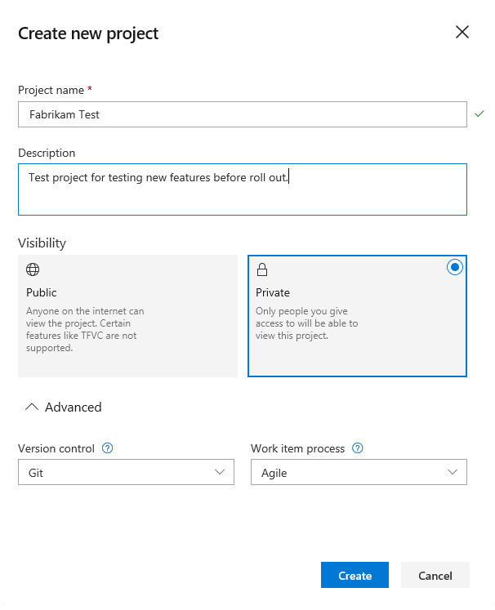

When you choose public visibility, anyone on the internet can view your project. With private visibility, only users you give access to can view your project. For more information about features and access levels for public projects, see [Make a private project public](https://learn.microsoft.com/en-us/azure/devops/organizations/projects/make-project-public?view=azure-devops). If the **Public** option isn't available, you need to change the policy.

1. Select **Create**. Azure DevOps displays the project welcome page.

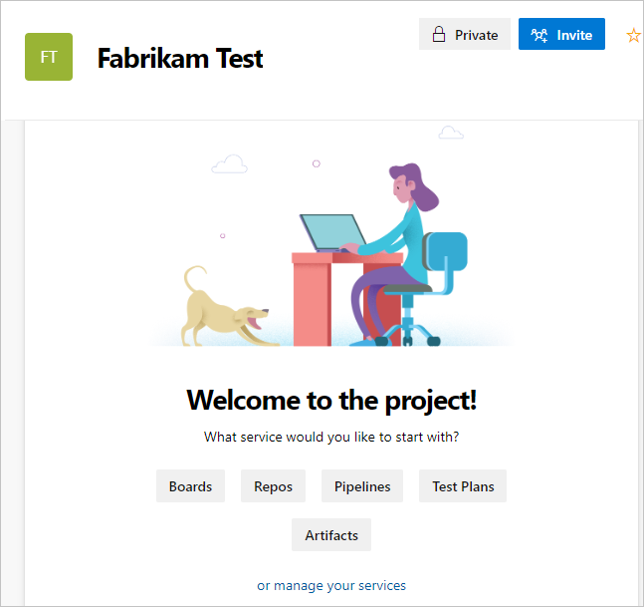

Select one of the following options to continue:

* + **Invite**: Add others to your project. See [Add users to a project or team](https://learn.microsoft.com/en-us/azure/devops/organizations/security/add-users-team-project?view=azure-devops). You can only invite users who are already in your organization. For more information, see [Add users to a project](https://learn.microsoft.com/en-us/azure/devops/organizations/security/add-users-team-project?view=azure-devops#add-users-to-a-project).
  + **Boards**: Add work items. See [View and add work items using the Work Items page](https://learn.microsoft.com/en-us/azure/devops/boards/work-items/view-add-work-items?view=azure-devops).
  + **Repos**: Clone or import a repository or initialize a *README* file for your project summary page. See [Clone an existing Git repo](https://learn.microsoft.com/en-us/azure/devops/repos/git/clone?view=azure-devops).
  + **Pipelines**: Define a pipeline. See [Azure Pipelines documentation](https://learn.microsoft.com/en-us/azure/devops/pipelines/?view=azure-devops).
  + **Test Plans**: Define test plans and test suites. See [Create test plans and test suites](https://learn.microsoft.com/en-us/azure/devops/test/create-a-test-plan?view=azure-devops).
  + **Artifacts**: Discover, install, and publish NuGet, npm, and Maven packages. See the [Azure Artifacts overview](https://learn.microsoft.com/en-us/azure/devops/artifacts/start-using-azure-artifacts?view=azure-devops).
  + **manage your services**: Disable the visibility of services. See [Turn a service on or off](https://learn.microsoft.com/en-us/azure/devops/organizations/settings/set-services?view=azure-devops).

**List projects**

* [Browser](https://learn.microsoft.com/en-us/azure/devops/organizations/projects/create-project?view=azure-devops&tabs=browser#tabpanel_2_browser)
* [Team Explorer](https://learn.microsoft.com/en-us/azure/devops/organizations/projects/create-project?view=azure-devops&tabs=browser#tabpanel_2_team-explorer)
* [Azure DevOps CLI](https://learn.microsoft.com/en-us/azure/devops/organizations/projects/create-project?view=azure-devops&tabs=browser#tabpanel_2_azure-devops-cli)

View a list of projects from your web browser.

1. Sign in to your organization (https://dev.azure.com/{yourorganization}).
2. Select **Organization settings** and then select **Projects**.

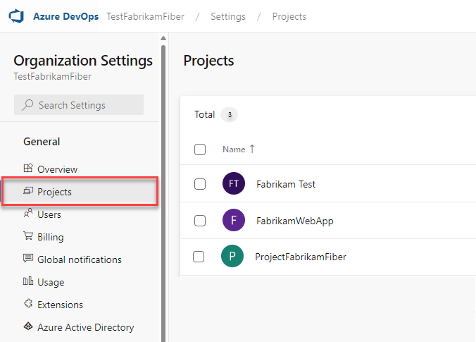

Open your desired project. For more information, see [About settings at the user, team, project, or organization-level](https://learn.microsoft.com/en-us/azure/devops/organizations/settings/about-settings?view=azure-devops).